Thyroid Disease Detection

***Wireframe Documentation***

|  |  |  |  |
| --- | --- | --- | --- |
| **Date Issued** | **Version** | **Description** | **Author** |
| 15-08-2022 | 1 | Wireframe-V1.0 | Surya Pranav |
|  |  |  |  |

Homepage

We will have a single page UI which will facilitate bulk prediction for Thyroid Disease Detection.

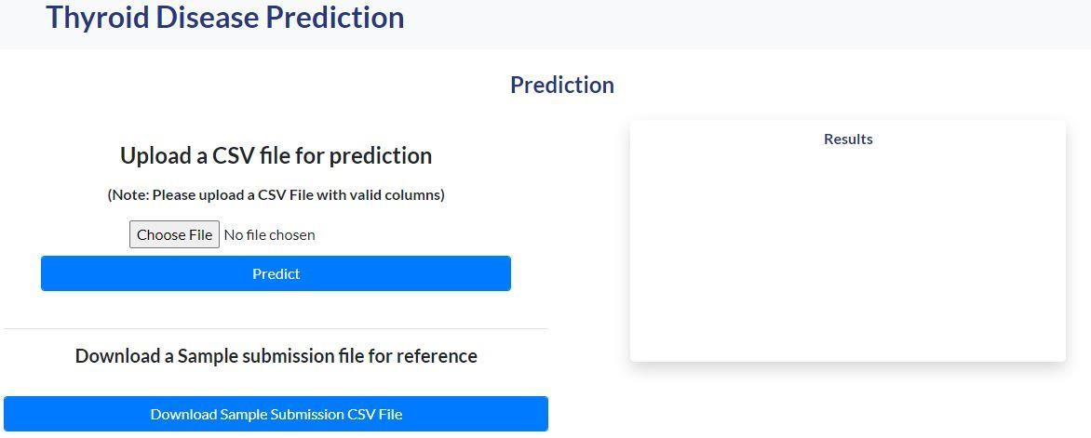

1. First thing anyone will see is a pop-up window on Homepage which will ask for CSV file for prediction.

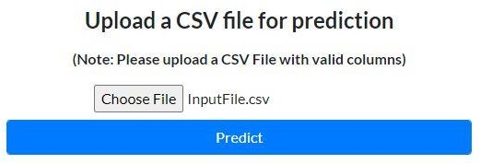

1. After choosing the csv file for prediction, user has to click on predict button for prediction. And then on right side a new pop up window will come which give option to download the prediction in csv file format.

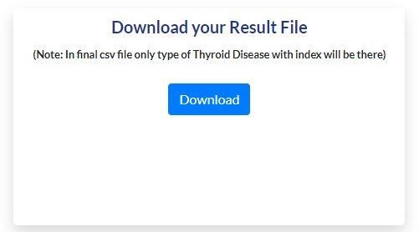

Prediction CSV file will contain index with type of Thyroid Disease particular patient is suffering from.

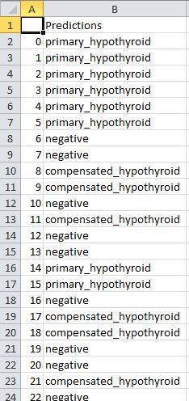

At last we will have an option which enable user to download sample submission CSV file for reference.

